Java 8 Features..

Java 8 introduced several new features that enhanced the language's capabilities: Lambda expressions allow for more concise and functional programming by providing a way to pass behaviour as arguments to methods. The Stream API provides a fluent interface for processing collections of data using functional-style operations like filter, map, and reduce. The Optional class helps avoid NullPointerExceptions by encapsulating a value that may or may not be present. Default and static methods in interfaces enable extending interfaces without breaking existing implementations.

Methods:-

1.Lambda Expression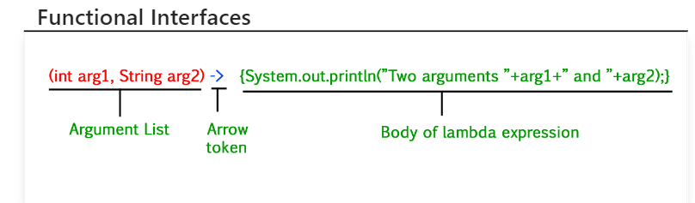

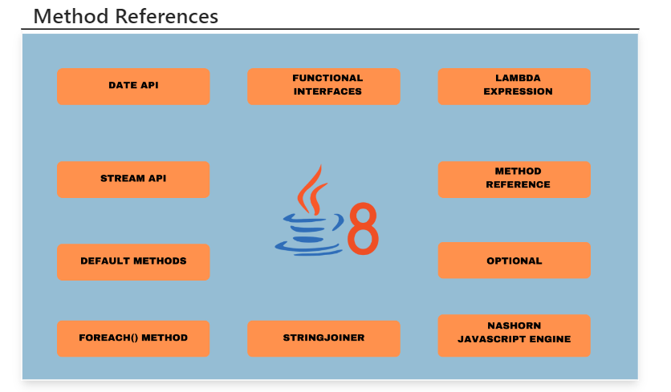

2.Streams

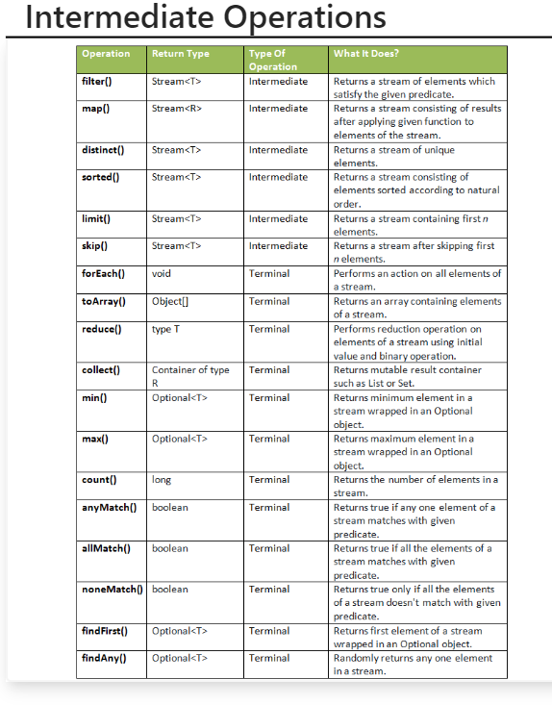

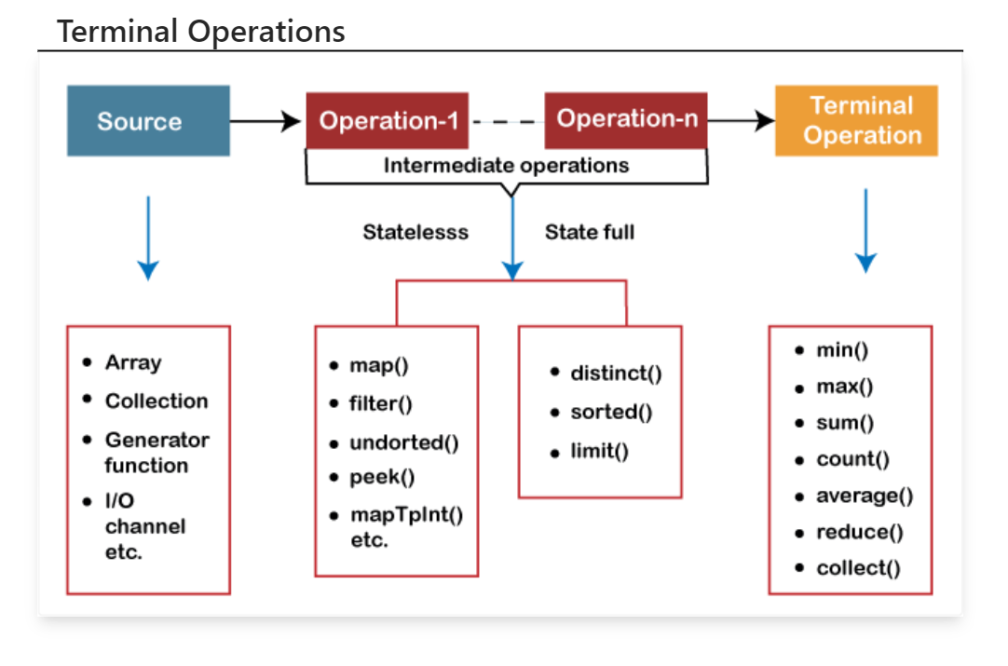

3.Optional

